**cloud computing**

**Lab 08**

**Name:** Abiha Nadeem

**Roll no:** 2023-BSE-001

**Submitted to:** Engr. Muhammad Shoaib

**AWS: Account Setup, IAM, VPC Inventory, EC2, Docker & Gitea**

**Task 1 — Create an AWS account and enable UAE (me-central-1)**

1. **Open your browser and go to:**[**AWS Signup**](https://signin.aws.amazon.com/signup?request_type=register)

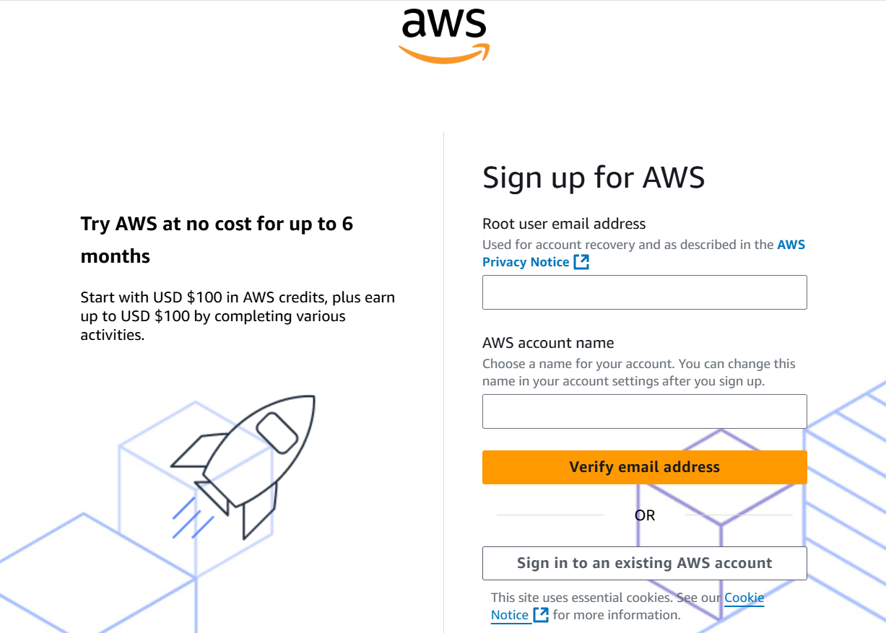

**Save screenshot as: task1_open_signup_page.png — browser showing the signup page.**

1. **Complete registration (Account type: Personal, Plan: AWS Paid Plan), fill contact, billing (credit card) and phone details, complete verification. After successful registration capture:**

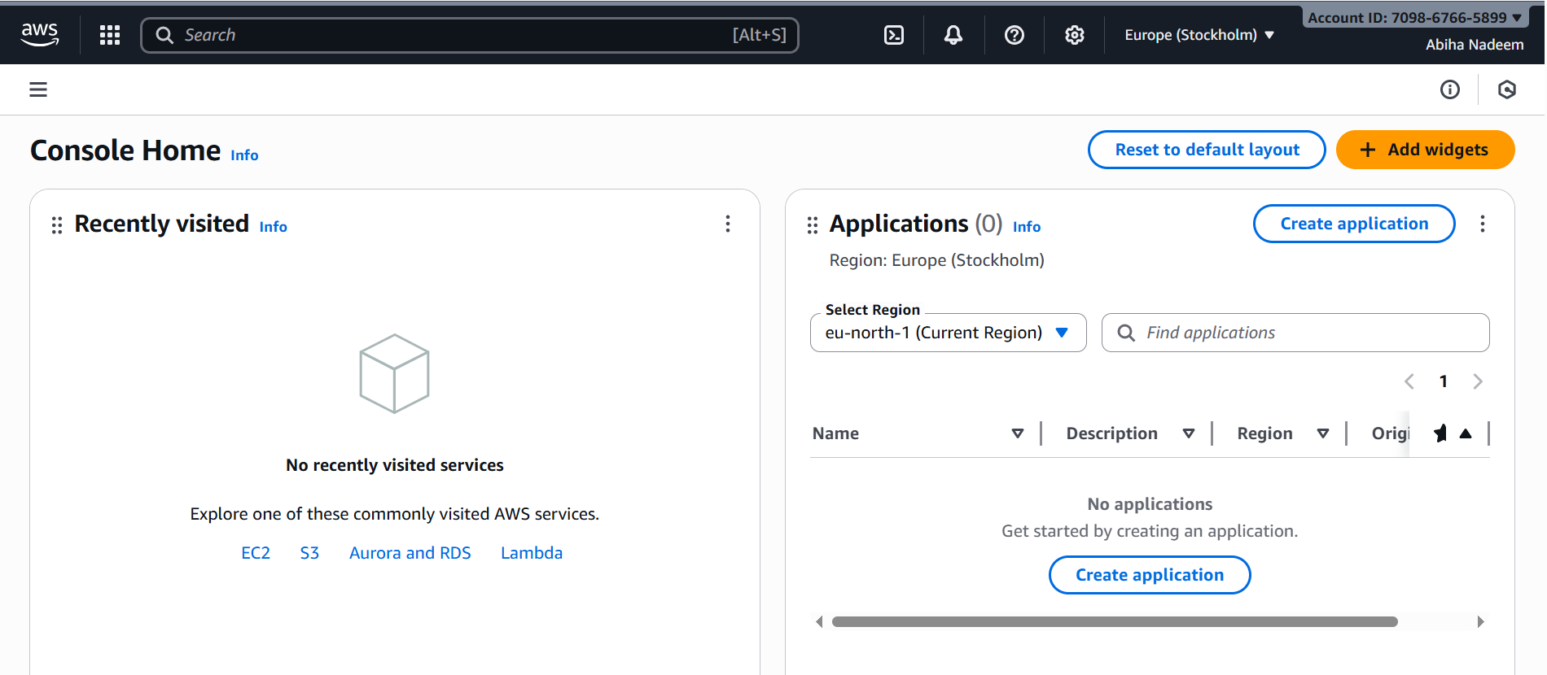

**Save screenshot as: task1_signed_up_confirmation.png — registration success/confirmation page or payment confirmation (do NOT include credit card full details).**

1. **Sign in as the root user (root email). Immediately capture:**



**Save screenshot as: task1_root_signed_in.png — AWS Console Home after root login (top bar with root email/account alias visible).**

1. **From the Console, open the region selector and enable UAE (me-central-1), then switch to me-central-1. Capture the change:**

**Save screenshot as: task1_enable_region_me-central-1.png — region selector showing me-central-1 selected.**

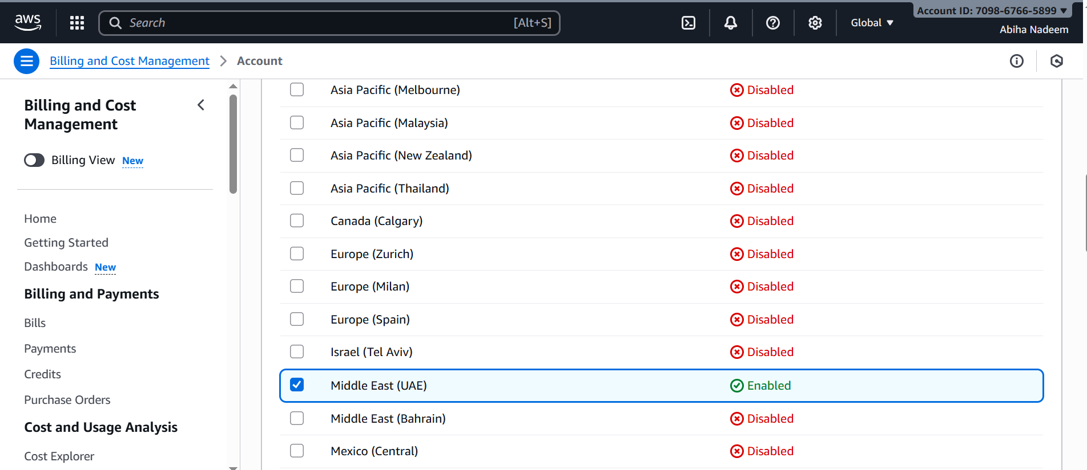

1. **Task 1 summary screenshot (combine evidence):**



**Save screenshot as: task1_summary.png — single screenshot showing root console header (root email/account alias) and region set to me-central-1.**

**Task 2 — Create IAM Admin and Lab8User with console access**

1. **Open IAM via Console search (Alt+S → "IAM").**

**Save screenshot as: task2_open_iam_console.png — IAM console landing page (region me-central-1 visible).**

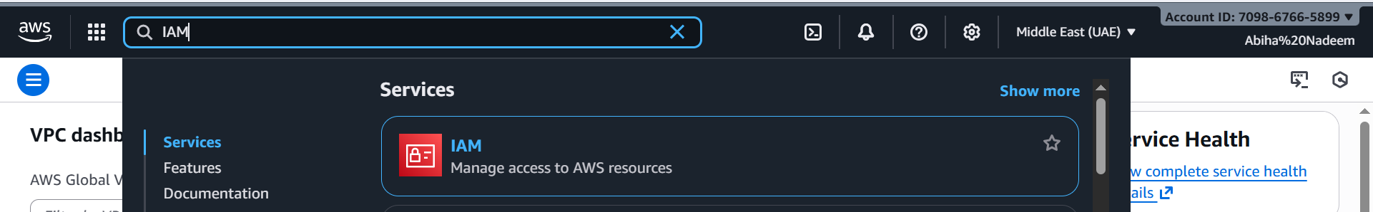

1. **Create the Admin user: IAM → Users → Create user. Fill:**

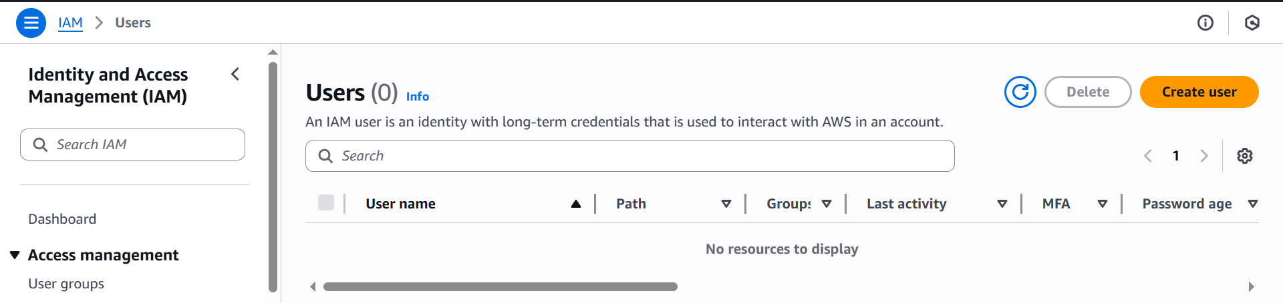

* Username: Admin
* Provide user access to the AWS Management Console
* Set console password (autogenerate or set)

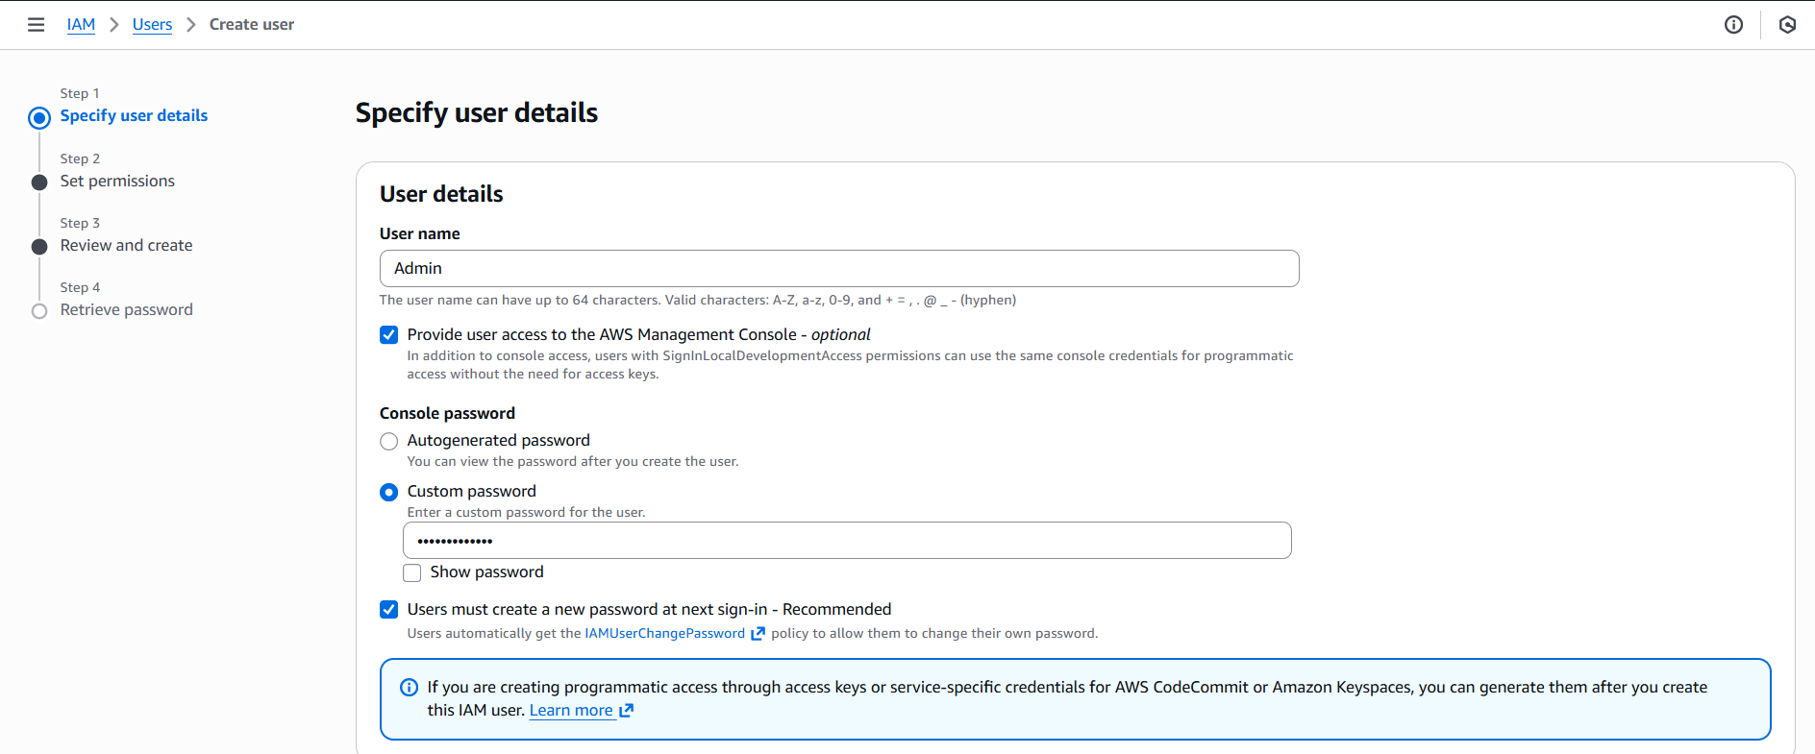

* Attach policies directly → AdministratorAccess

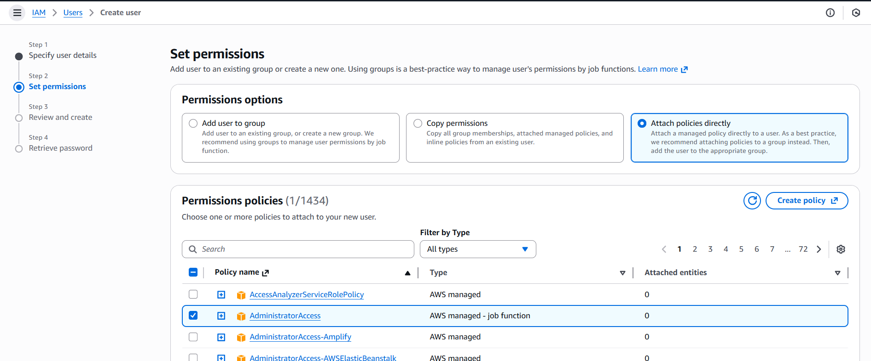

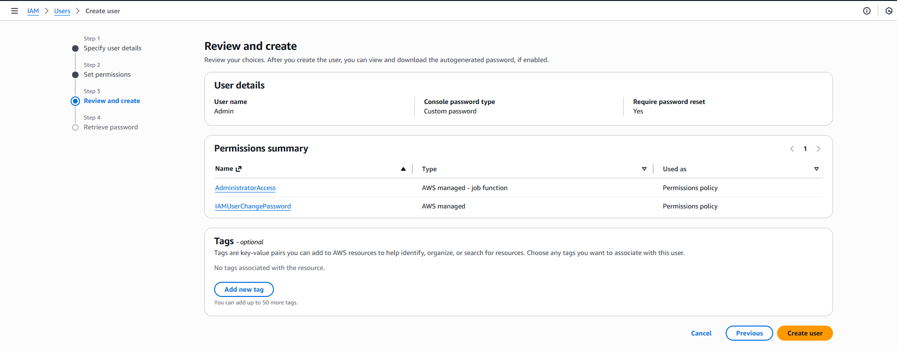

* Capture the completion screen when user is created:

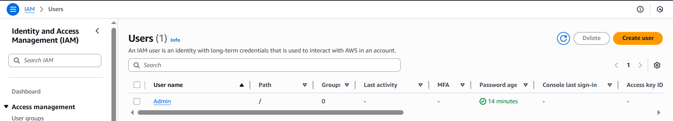

**Save screenshot as: task2_admin_create_confirmation.png — IAM "Create user" success screen showing Admin (do NOT include password).**

1. **Download the Admin .csv and show its presence on your Windows host (do not display the password text):**

**Save screenshot as: task2_admin_csv_and_signin_url.png — Windows File Explorer showing the downloaded CSV filename and/or a cropped view of the CSV showing only the Sign-in URL and username (redact the password if visible).**

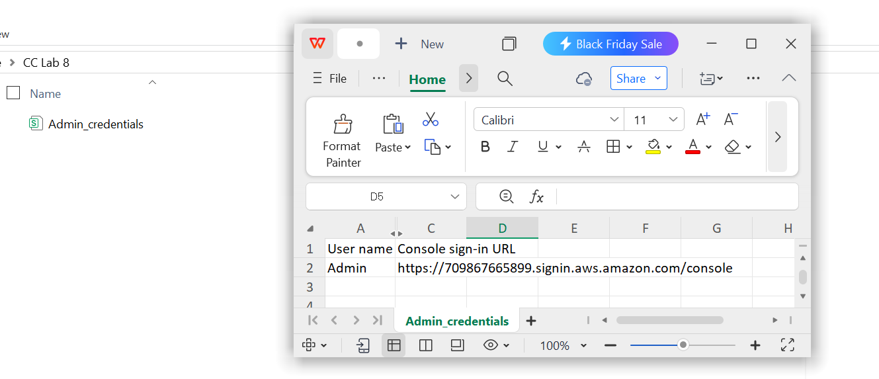

1. **Sign out of root, then sign in using the Admin account (use the signin URL from the .csv). Capture after successful Admin login:**

**Save screenshot as: task2_admin_console_after_login.png — Admin user console home.**

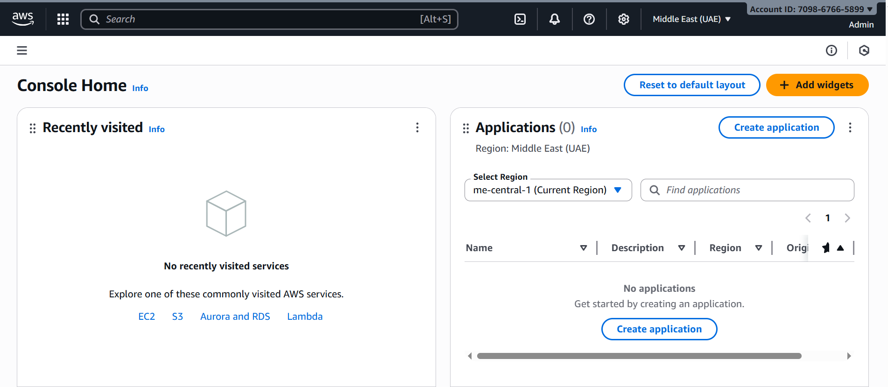

1. **While logged in as Admin, create Lab8User:**
   1. IAM → Users → Create user

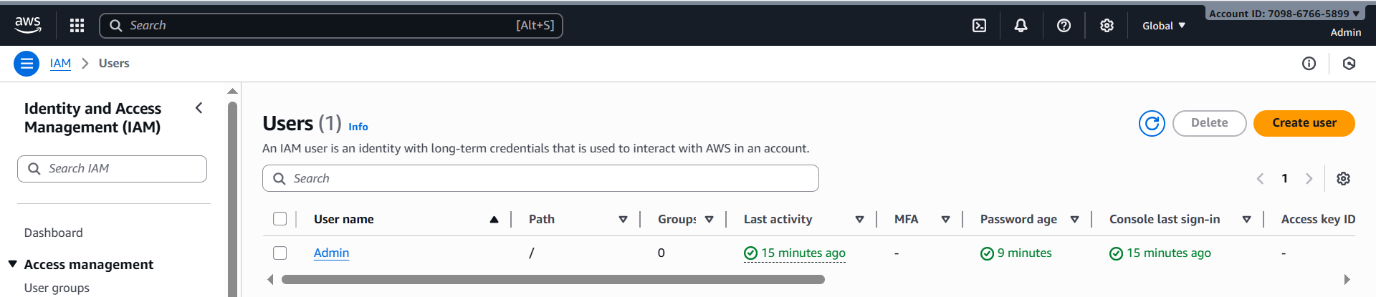

* 1. Username: Lab8User

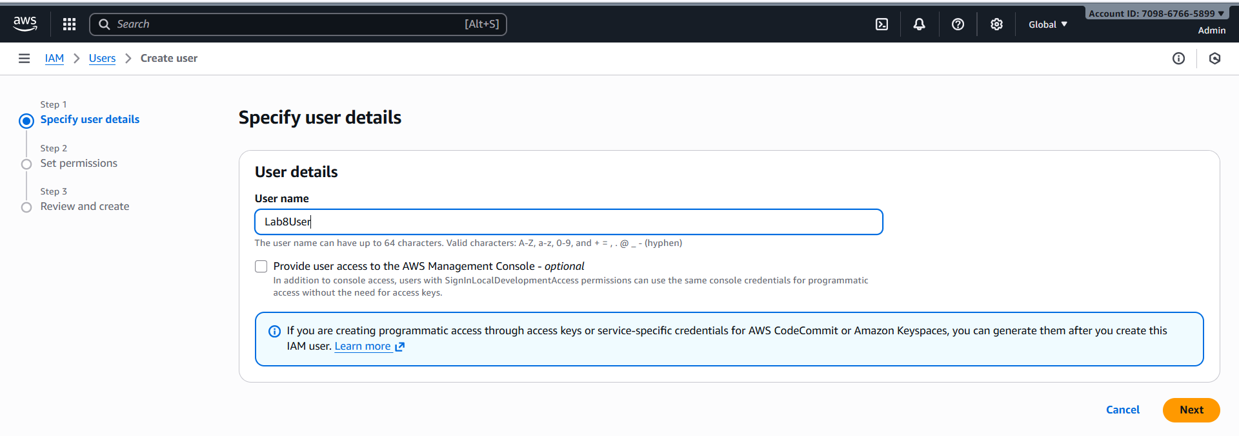

* 1. Provide user access to the AWS Management Console

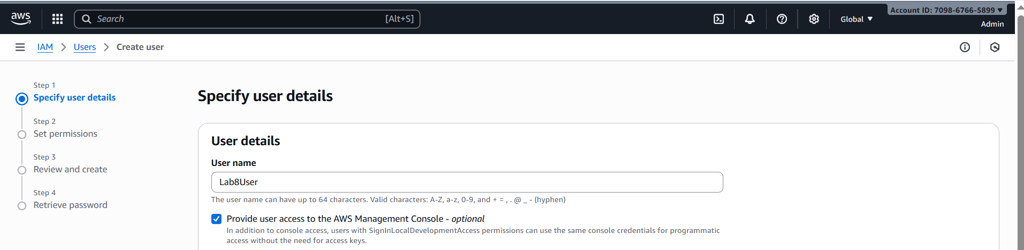

* 1. Attach AdministratorAccess policy

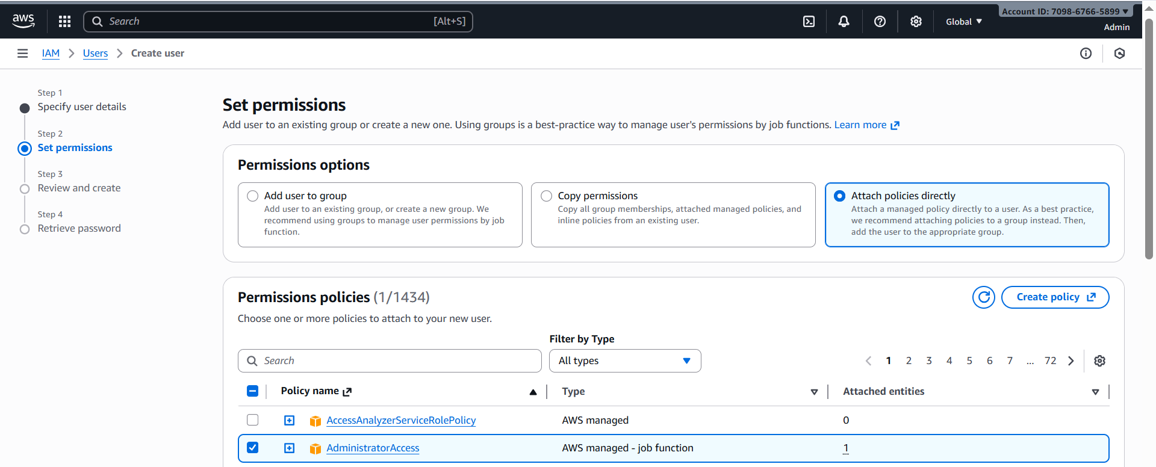

Capture the create-user success screen:

**Save screenshot as: task2_create_lab8user_and_csv.png — Lab8User create confirmation and CSV download prompt (do NOT include password).**

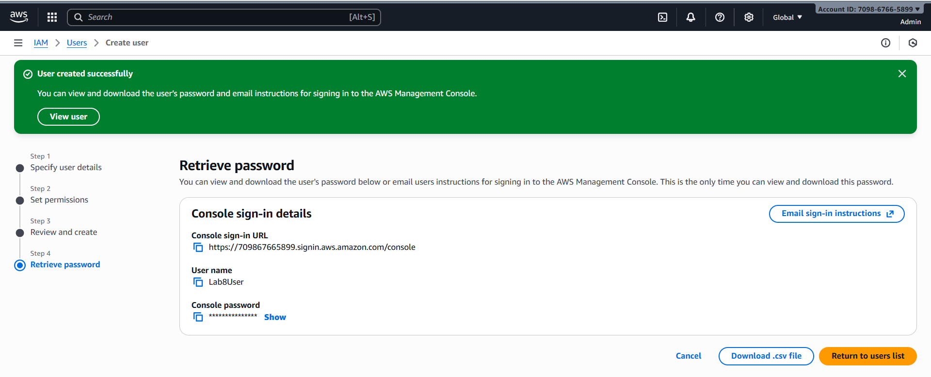

1. **Download/save the Lab8User CSV on your Windows host (do not show password).**

**Save screenshot as: task2_lab8user_csv_saved.png — File Explorer showing the Lab8User CSV filename (cropped to exclude sensitive content).**

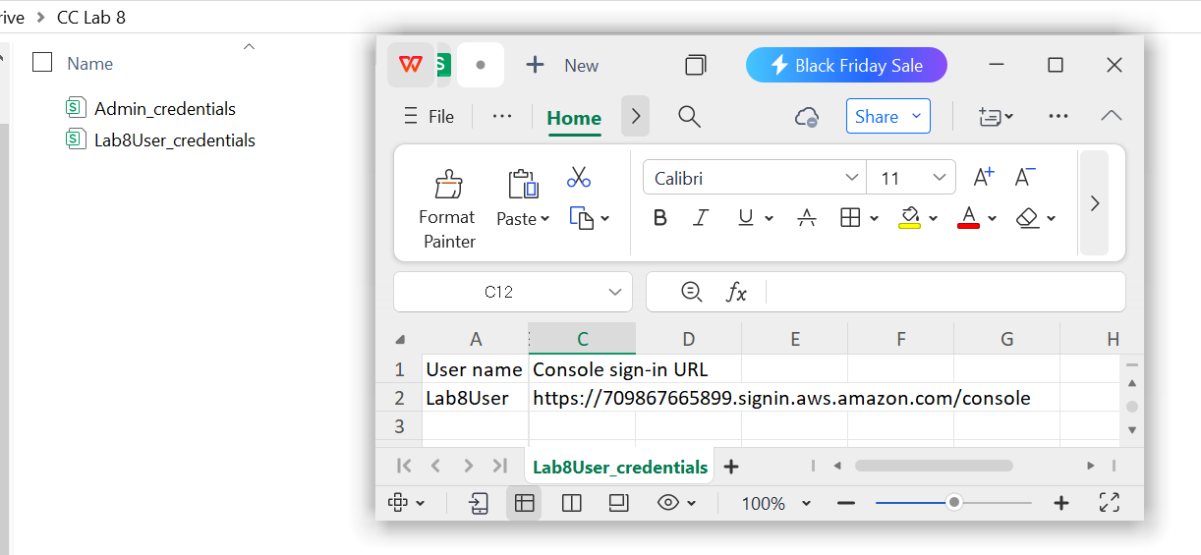

1. **Logout Admin and login as Lab8User (use the Lab8User signin URL and credentials). Capture after login:**

**Save screenshot as: task2_lab8user_logged_in.png — Lab8User console home.**

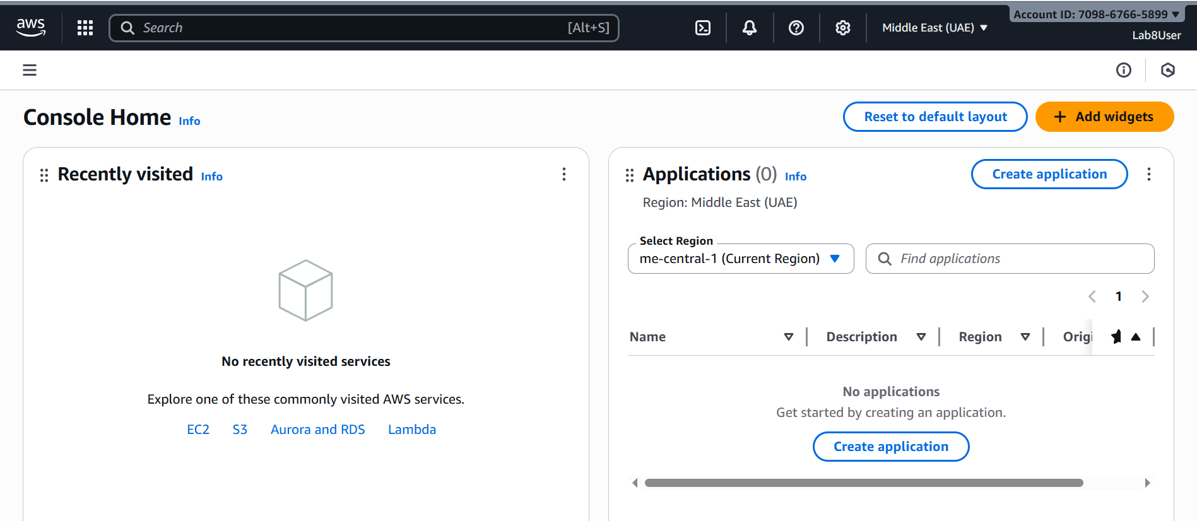

1. **Task 2 summary (combine evidence):**

**Save screenshot as: task2_summary.png — IAM Users list showing both Admin and Lab8User present (region me-central-1 visible).**

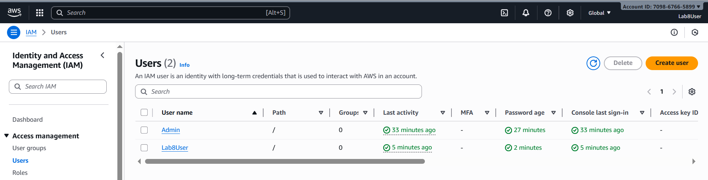

**Task 3 — Inspect VPC resources (in UAE me-central-1)**

1. **Open VPC console (Alt+S → "VPC") while region is me-central-1.**

**Save screenshot as: task3_open_vpc_console.png — VPC console landing page (region visible).**

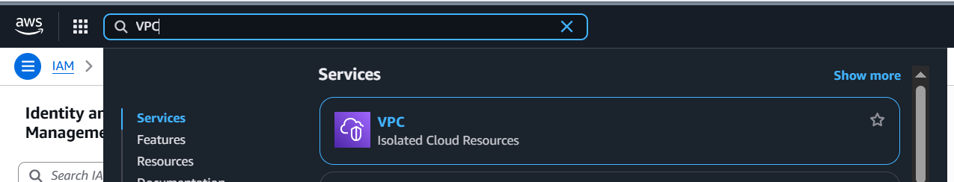

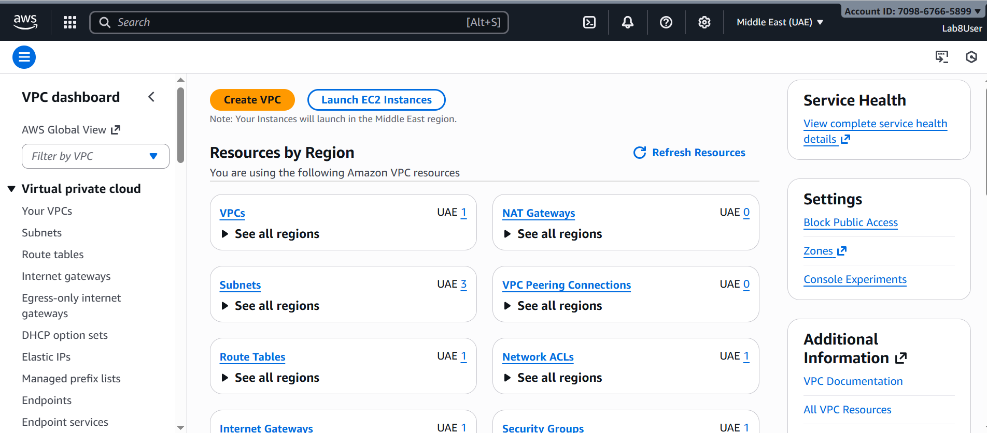

1. **View VPCs list. Capture:**

**Save screenshot as: task3_vpcs_list.png — VPCs list view (show default VPC if present).**

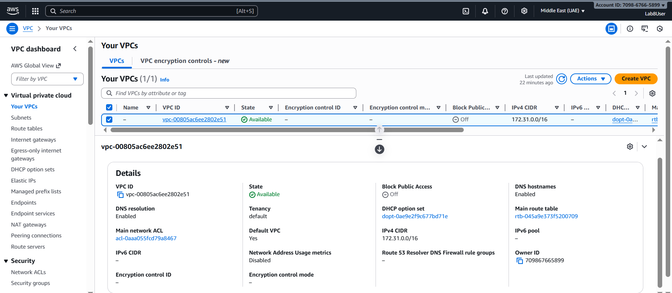

1. **View Subnets list. Capture:**

**Save screenshot as: task3_subnets_list.png — Subnets list view (show at least 3 default subnets if present).**

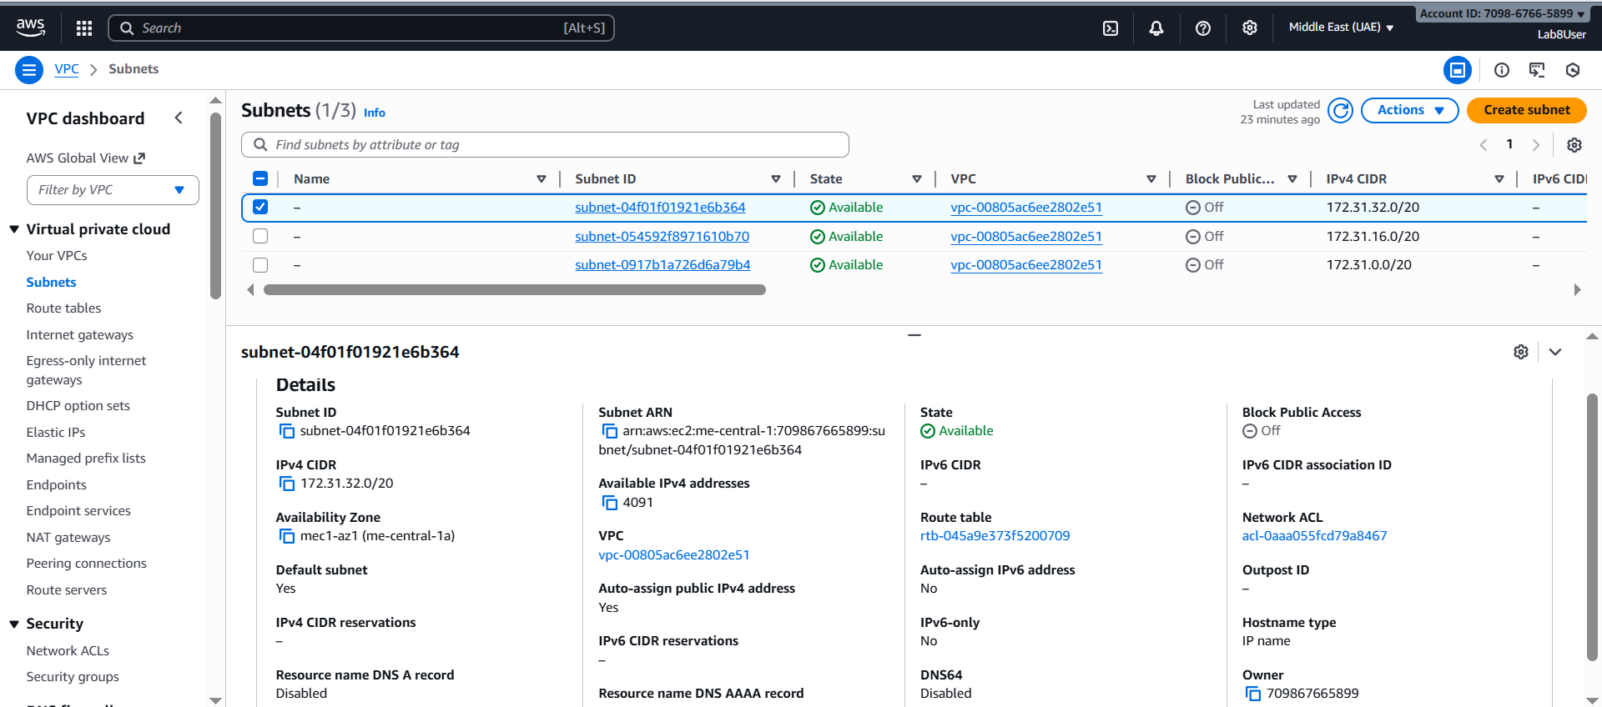

1. **View Route Tables list. Capture:**

**Save screenshot as: task3_route_tables_list.png — Route Tables list view.**

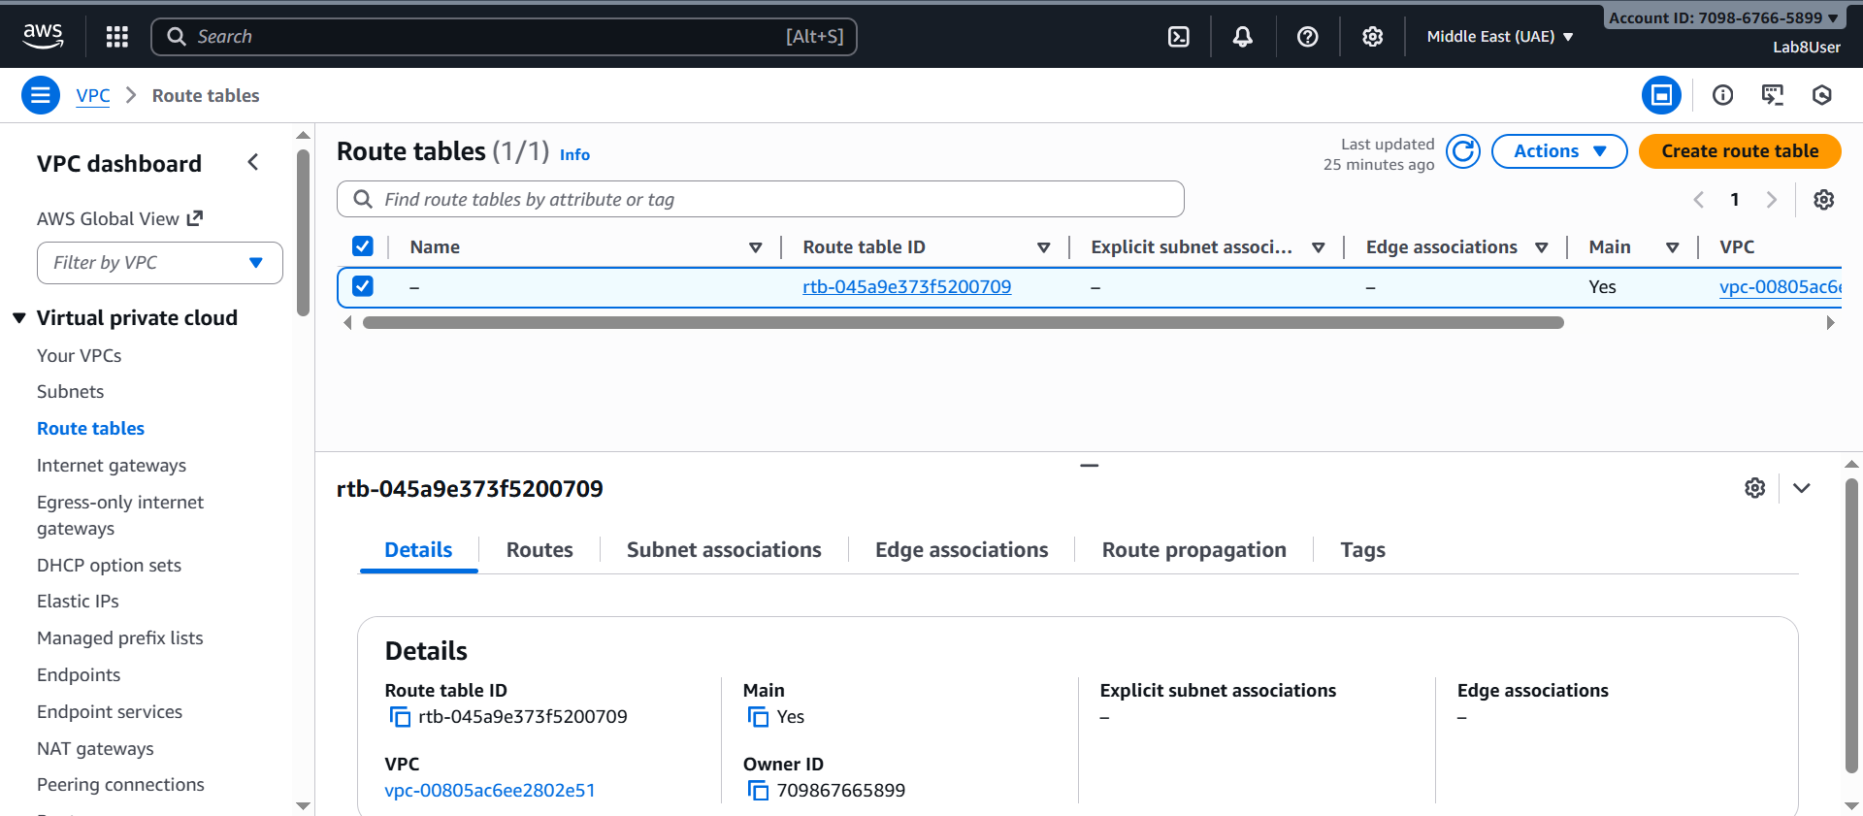

1. **View Network ACLs list. Capture:**

**Save screenshot as: task3_network_acls_list.png — Network ACLs list view.**

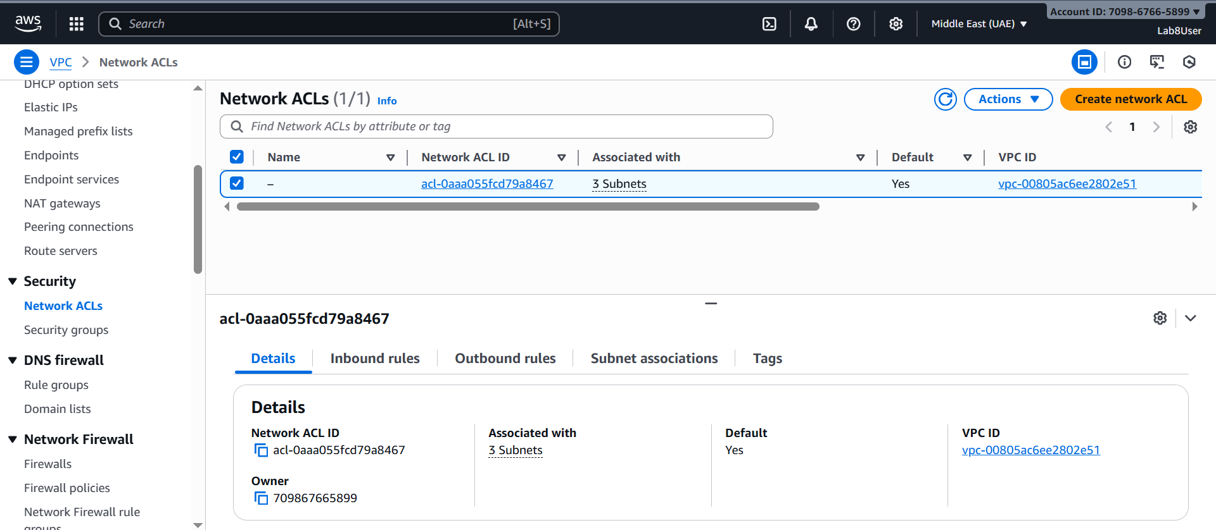

1. **Task 3 summary (combine evidence):**

**Save screenshot as: task3_summary.png — a single screenshot showing the VPC console left navigation and counts or multiple open tabs/windows tiled to show each resource's list (region me-central-1 visible).**

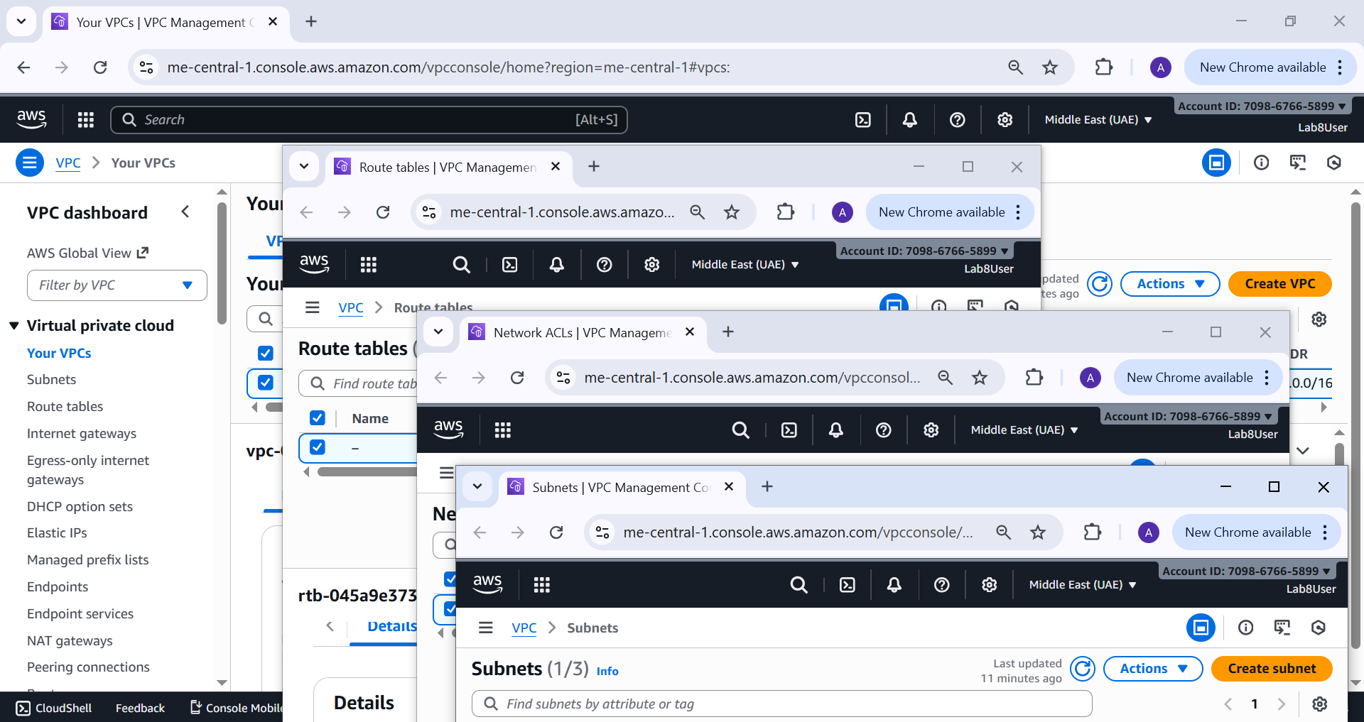

**Task 4 — Launch EC2, SSH, install Docker & Docker Compose, deploy Gitea**

1. **Open EC2 Console (Alt+S → "EC2") (me-central-1).**

**Save screenshot as: task4_open_ec2_console.png — EC2 console landing page with region visible.**

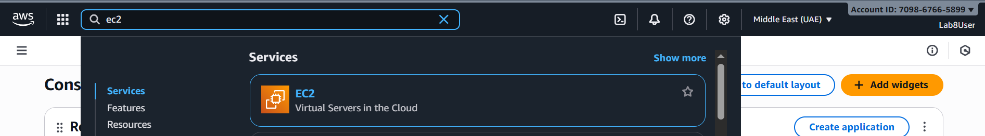

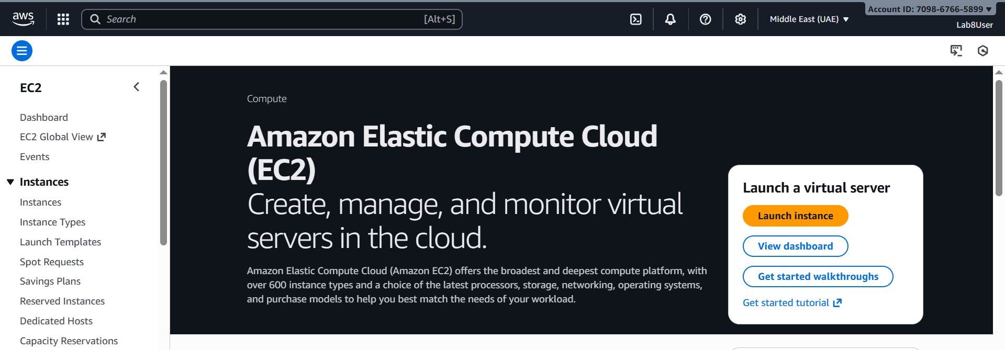

1. **Instance Launch configuration (during review before launching). Configure:**

* **Name: Lab8Machine**

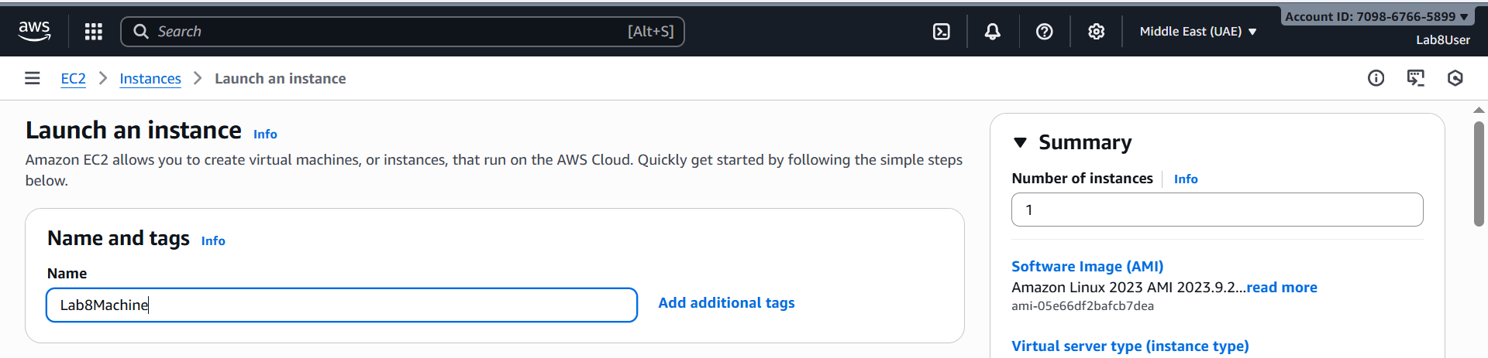

* **AMI: Amazon Linux 2**

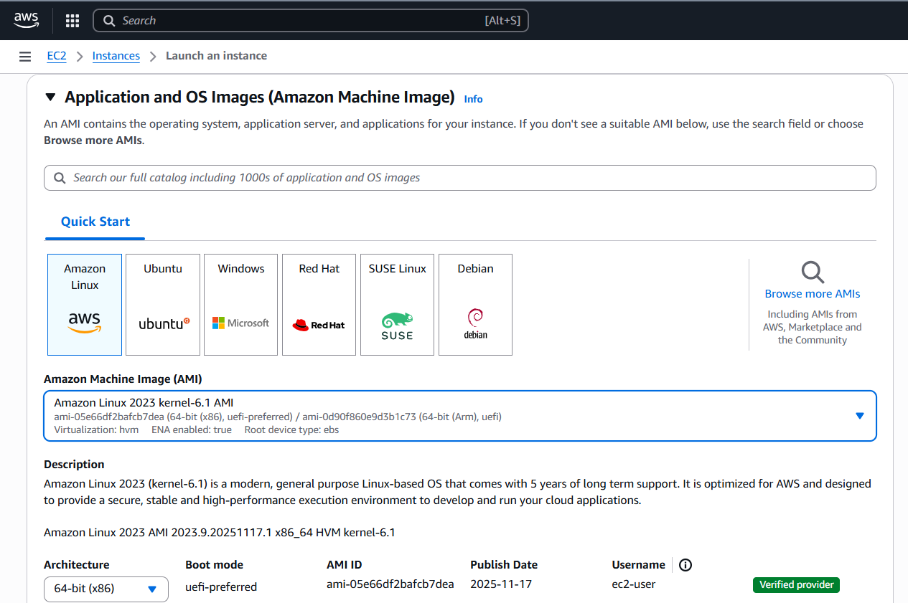

* **Instance type: t2.micro**

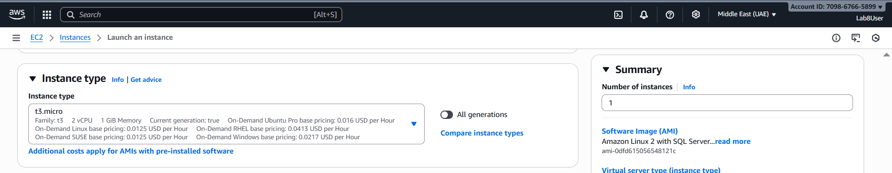

* **Security group: Create Lab8SecurityGroup with SSH from My IP**

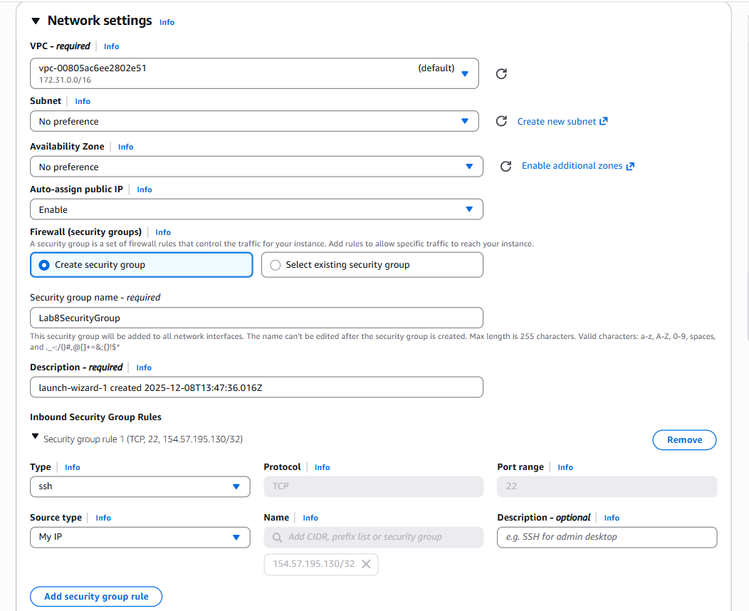

* **Storage: default**

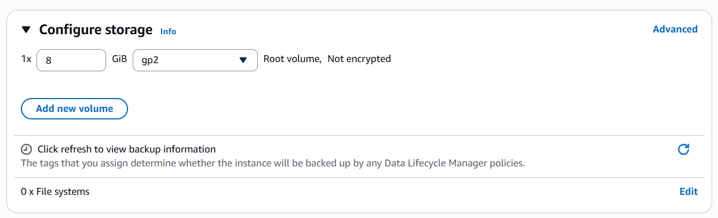

* **Key pair: Create Lab8Key (ED25519, .pem) and download the .pem file to your Windows host**
* **Capture the final review page and the key download prompt:**
* **Save screenshot as: task4_launch_instance_config.png — final review page showing instance name, AMI, type, security group, key pair.**

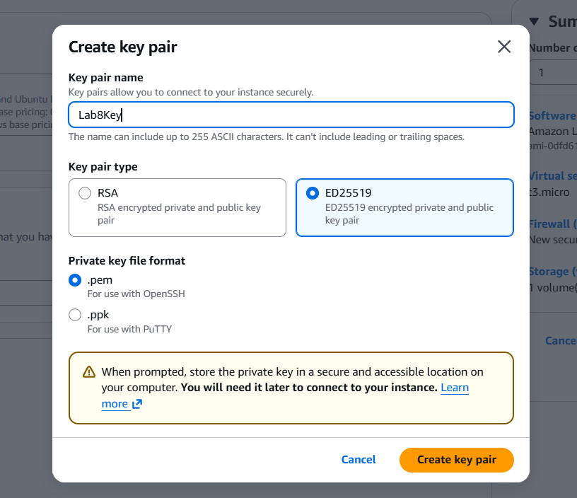

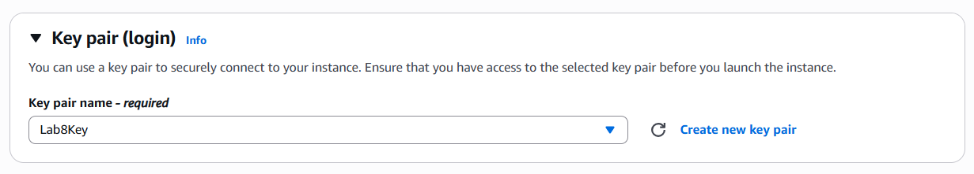

* **Save screenshot as: task4_keypair_download.png — Windows File Explorer showing Lab8Key.pem downloaded (do NOT open .pem contents).**

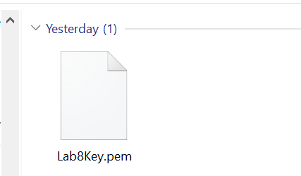

1. **After launch, EC2 Instances list showing Lab8Machine in "running" state and public IPv4 visible.**

**Save screenshot as: task4_instance_running_console.png — Instances table with Lab8Machine running and Public IPv4.**

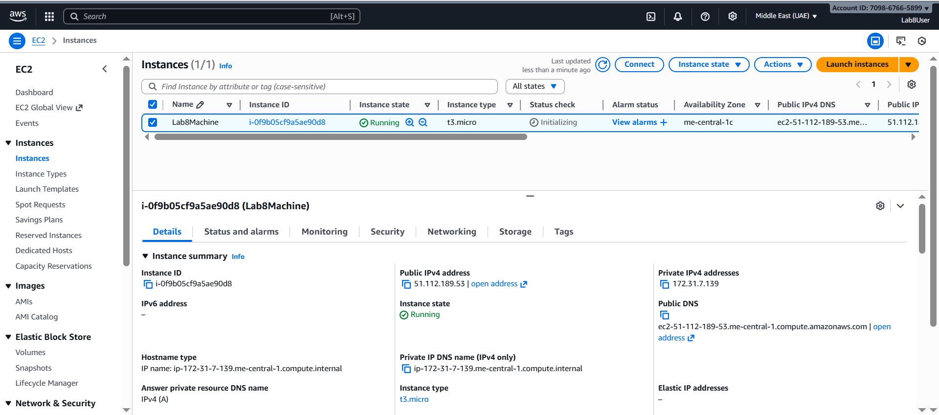

1. **On Windows host, run SSH using the downloaded .pem (PowerShell/Git Bash/Windows Terminal):**

ssh -i <path>/Lab8Key.pem ec2-user@<public-IP>

**Capture the SSH command and successful shell prompt on the EC2 instance:**

**Save screenshot as: task4_ssh_from_windows_to_ec2.png — PowerShell showing ssh command and EC2 shell (do NOT show private key contents).**

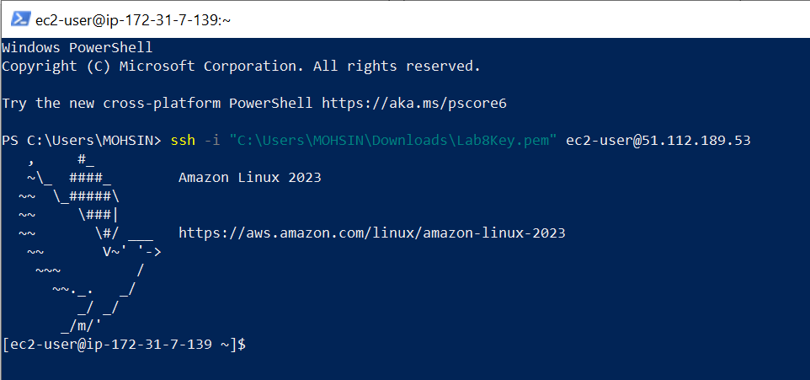

**5. Run the install commands on the EC2 shell:**

sudo yum update -y

sudo yum install -y docker

sudo mkdir -p /usr/local/lib/docker/cli-plugins

sudo curl -SL https://github.com/docker/compose/releases/latest/download/docker-compose-linux-x86_64 -o /usr/local/lib/docker/cli-plugins/docker-compose

sudo chmod +x /usr/local/lib/docker/cli-plugins/docker-compose

sudo systemctl start docker

**Capture the terminal showing these commands run and successful outputs:**

**Save screenshot as: task4_ec2_install_docker_compose_started.png — outputs of update/install and systemctl start.**

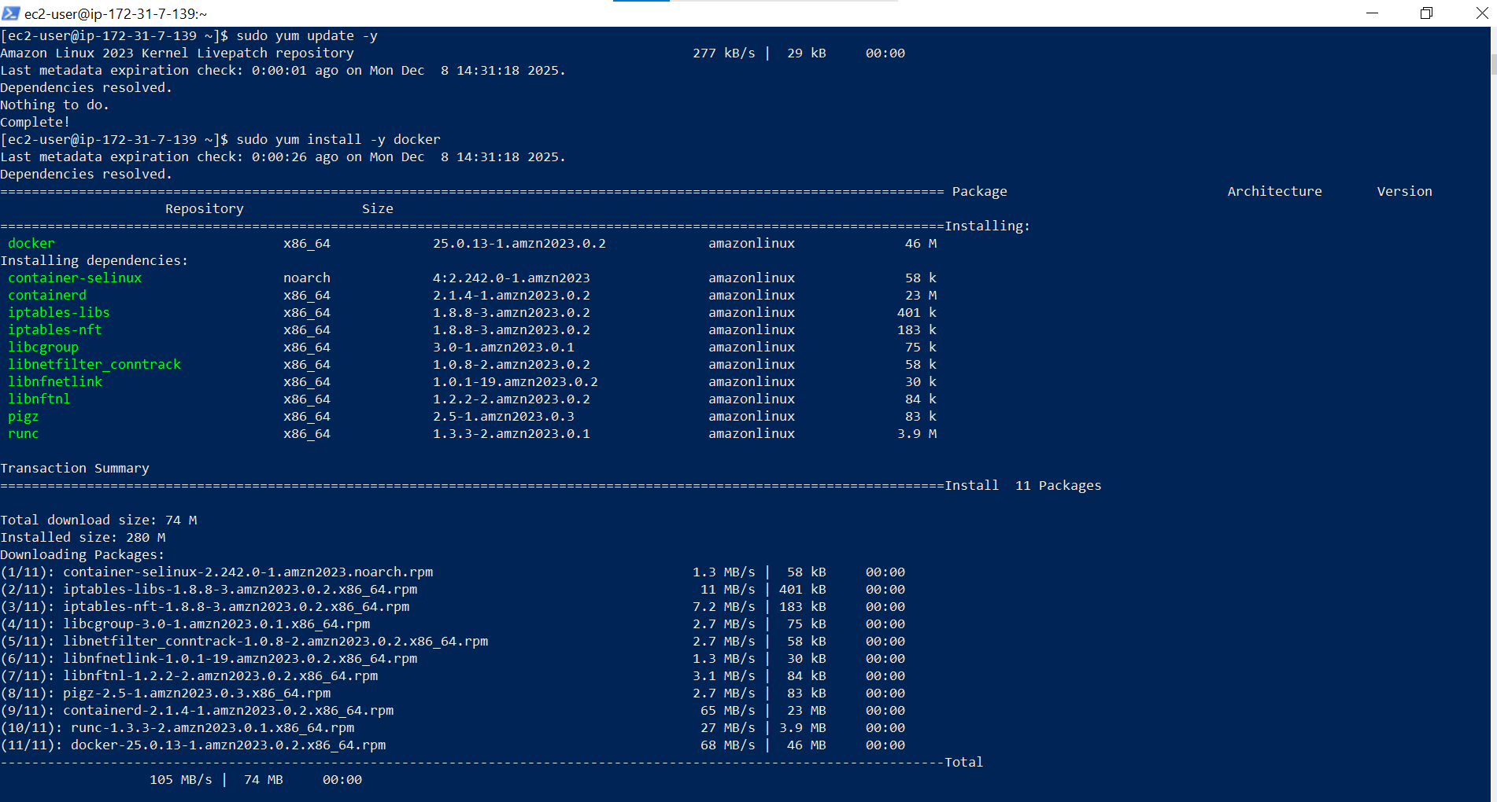

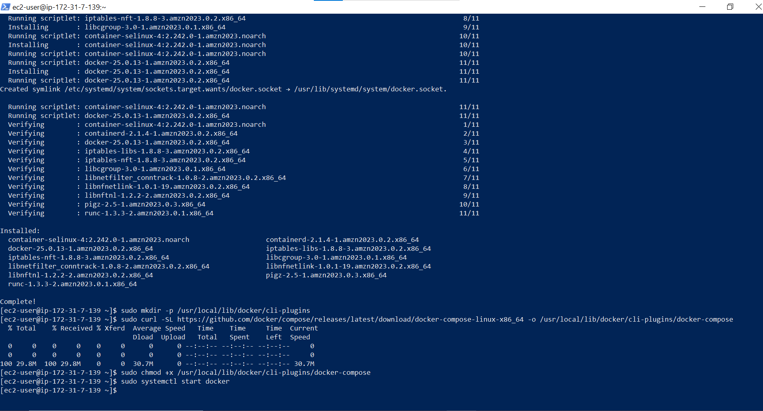

**6. Create/edit compose.yaml on the EC2 instance (sudo vim compose.yaml) and paste content from the repo: [Gitea](https://github.com/WaqasSaleem97/Gitea) . While pasting, capture the editor content:**

**Save screenshot as: task4_vim_compose_yaml_paste.png — vim editor showing compose.yaml contents while pasted.**

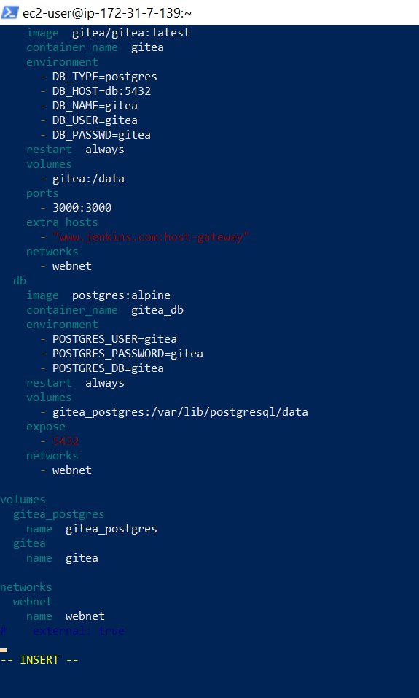

**7. Save and verify file exists:**

**Save screenshot as: task4_compose_yaml_saved_ls.png — ls -l showing compose.yaml present.**

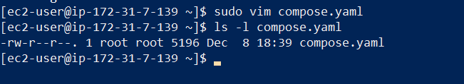

**8. Add ec2-user to docker group, show groups before re-login, exit and reconnect, show groups after reconnect:**

groups # user does not docker permission

sudo usermod -aG docker $USER

groups # before re-login

exit

# Reconnect

ssh -i <path>/Lab8Key.pem ec2-user@<public-IP>

groups # after re-login (should include docker)

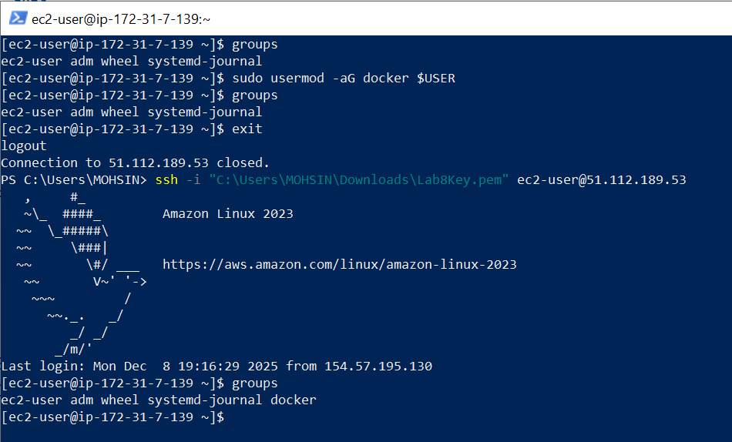

**Save screenshot as: task4_usermod_and_groups_before_after.png — show usermod command, groups output before exit, reconnect sequence, and groups output after (docker included).**

**9. Run docker compose up -d from the directory with compose.yaml:**

docker compose up -d

**Save screenshot as: task4_docker_compose_up.png — output of docker compose up -d showing containers starting.**

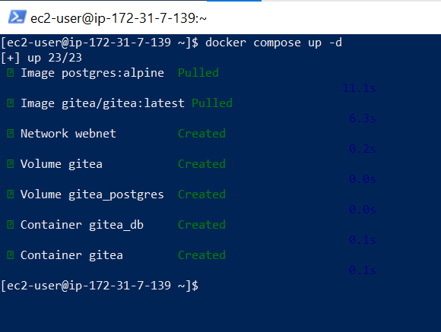

**10. Edit the security group Lab8SecurityGroup inbound rules in the EC2 console: add Custom TCP rule port 3000 source 0.0.0.0/0 and save. Capture the inbound rules after saving:**

**Save screenshot as: task4_security_group_allow_3000.png — security group inbound rules list showing SSH from My IP and Custom TCP 3000 anywhere.**

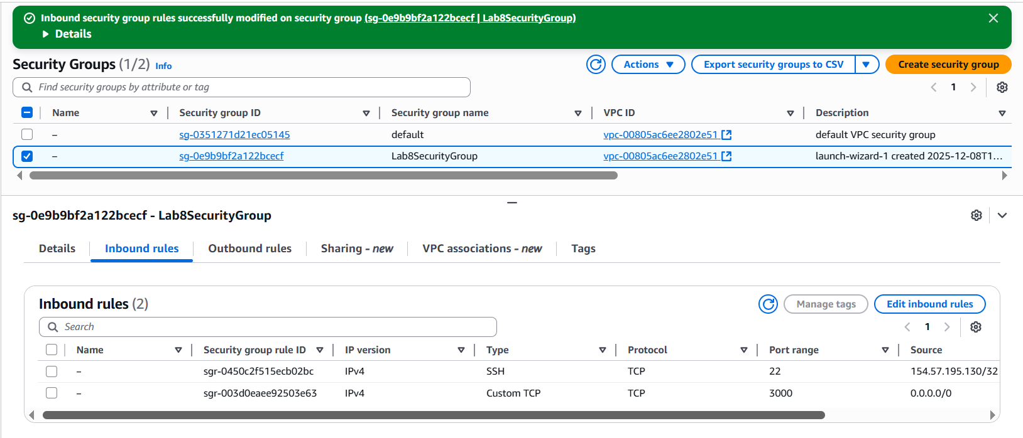

**11. From your Windows browser navigate to:**[**http://Public-IP:3000**](http://public-ip:3000/)**— capture the Gitea setup/install page:**

**Save screenshot as: task4_gitea_install_page.png — Gitea installation page in browser.**

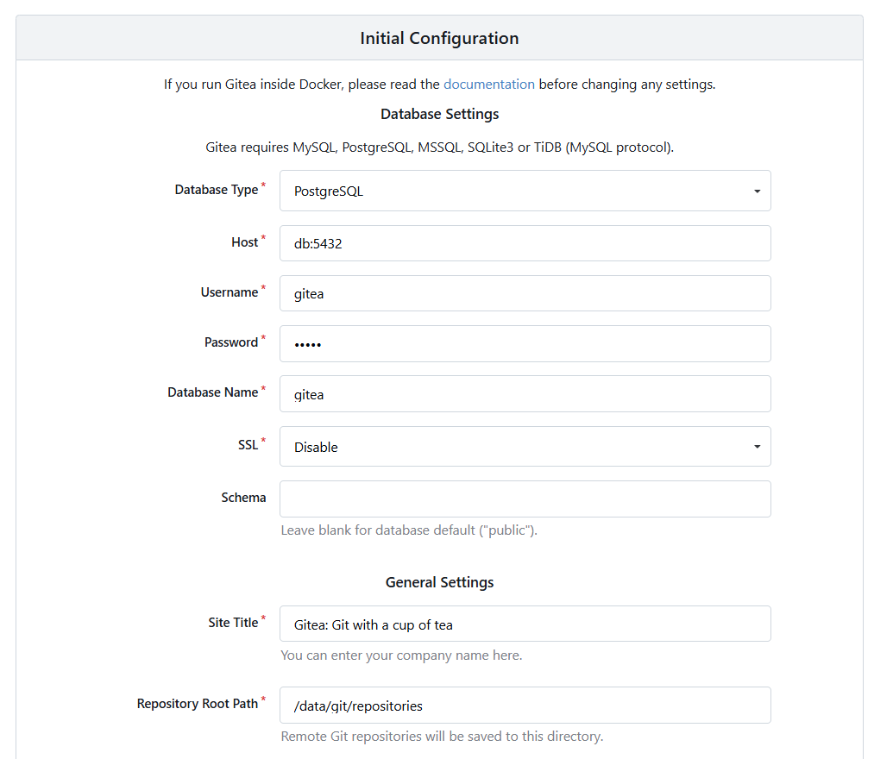

**12. Complete initial Gitea setup (create admin user, create a repo) and capture Gitea showing the created repository:**

**Save screenshot as: task4_gitea_create_repo.png — Gitea UI showing the created repository.**

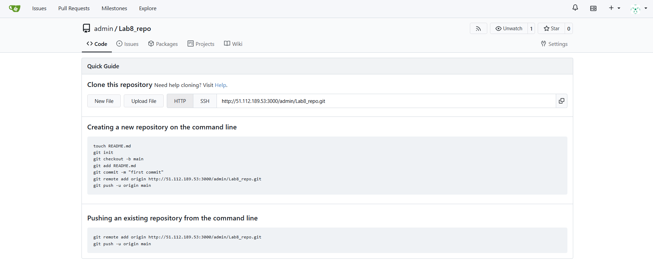

**13. Task 4 summary (combine evidence)**

**Save screenshot as: task4_summary.png — single screenshot (or tiled screenshot) showing: EC2 Instances list with Lab8Machine running and public IP, security group inbound rules showing SSH and port 3000, and browser tab open to Gitea UI or repo list.**

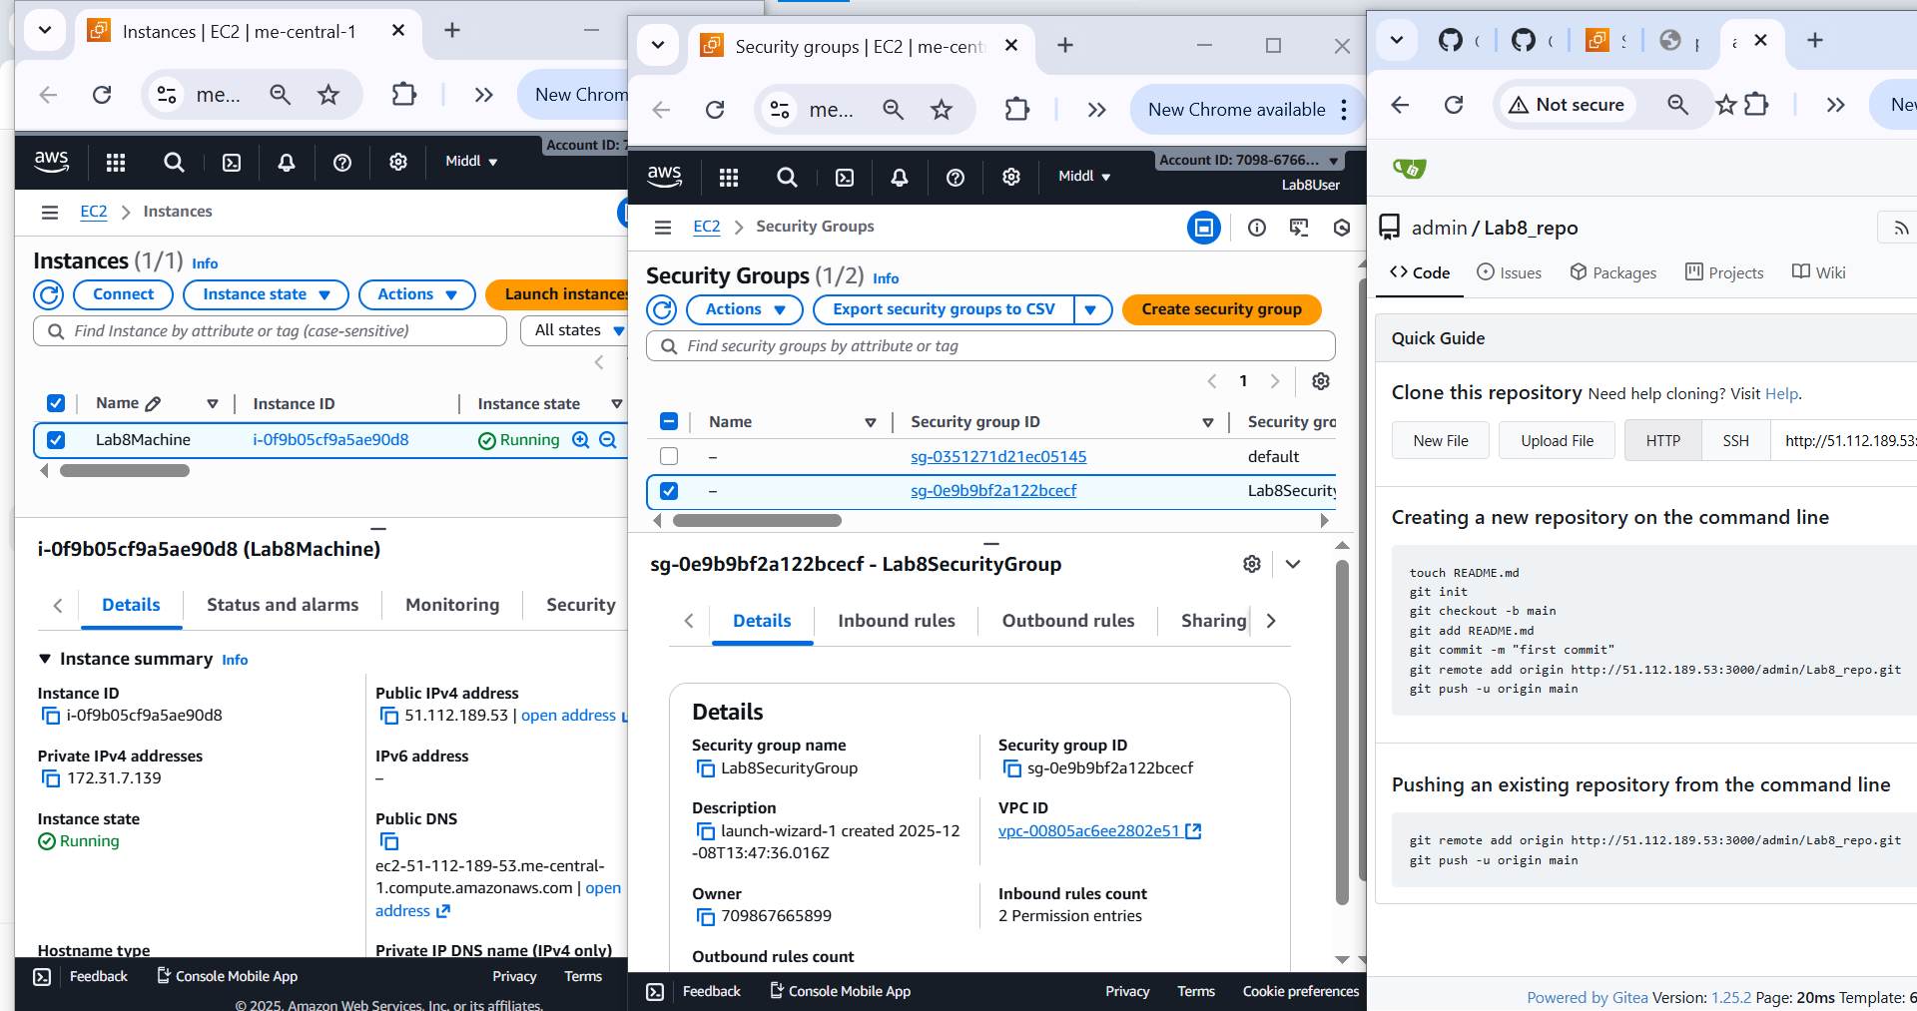

**Cleanup — Remove resources to avoid charges**

**After verification, terminate and delete everything you created. Capture screenshots immediately after each cleanup step.**

**Cleanup steps and required screenshots:**

1. **Terminate the EC2 instance Lab8Machine.**

**Save screenshot as: cleanup_terminate_instance.png — EC2 terminate instance confirmation.**

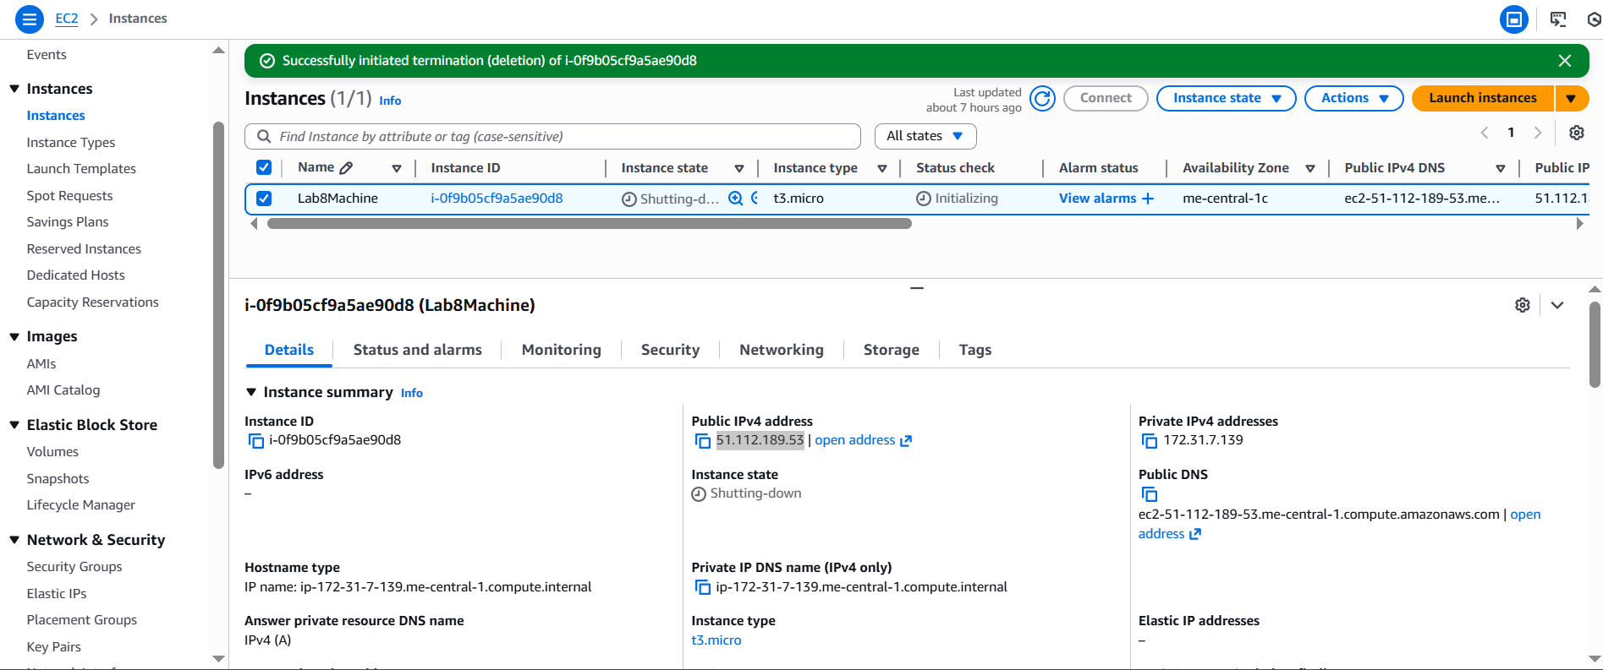

1. **Delete associated EBS volumes and snapshots (if any).**

**Save screenshot as: cleanup_delete_volumes_snapshots.png — confirmation or list showing volumes/snapshots deleted.**

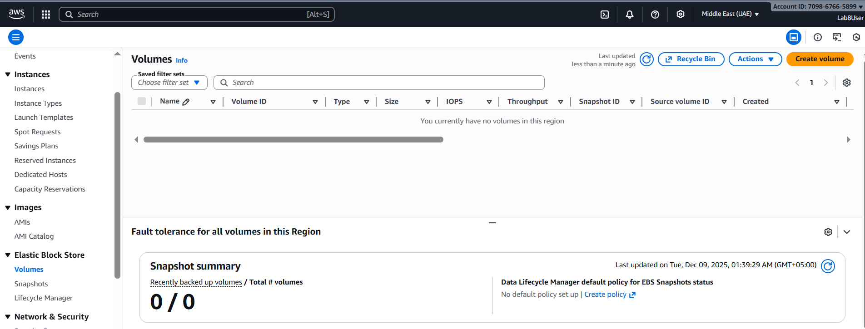

1. **Delete security group Lab8SecurityGroup and key pair Lab8Key from the EC2 console (after instances terminated).**

**Save screenshot as: cleanup_delete_security_group_and_keypair.png — deletion confirmation(s) (show key pair list and security group list after deletion).**

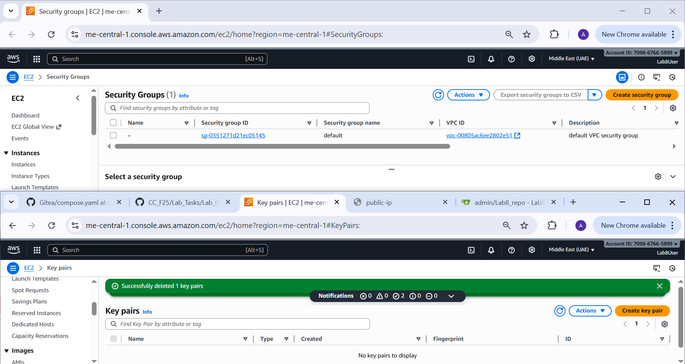

1. **Delete IAM users Lab8User and any access keys.**

**Save screenshot as: cleanup_iam_users_deleted.png — IAM Users list showing Lab8User no longer present (or a deletion confirmation).**

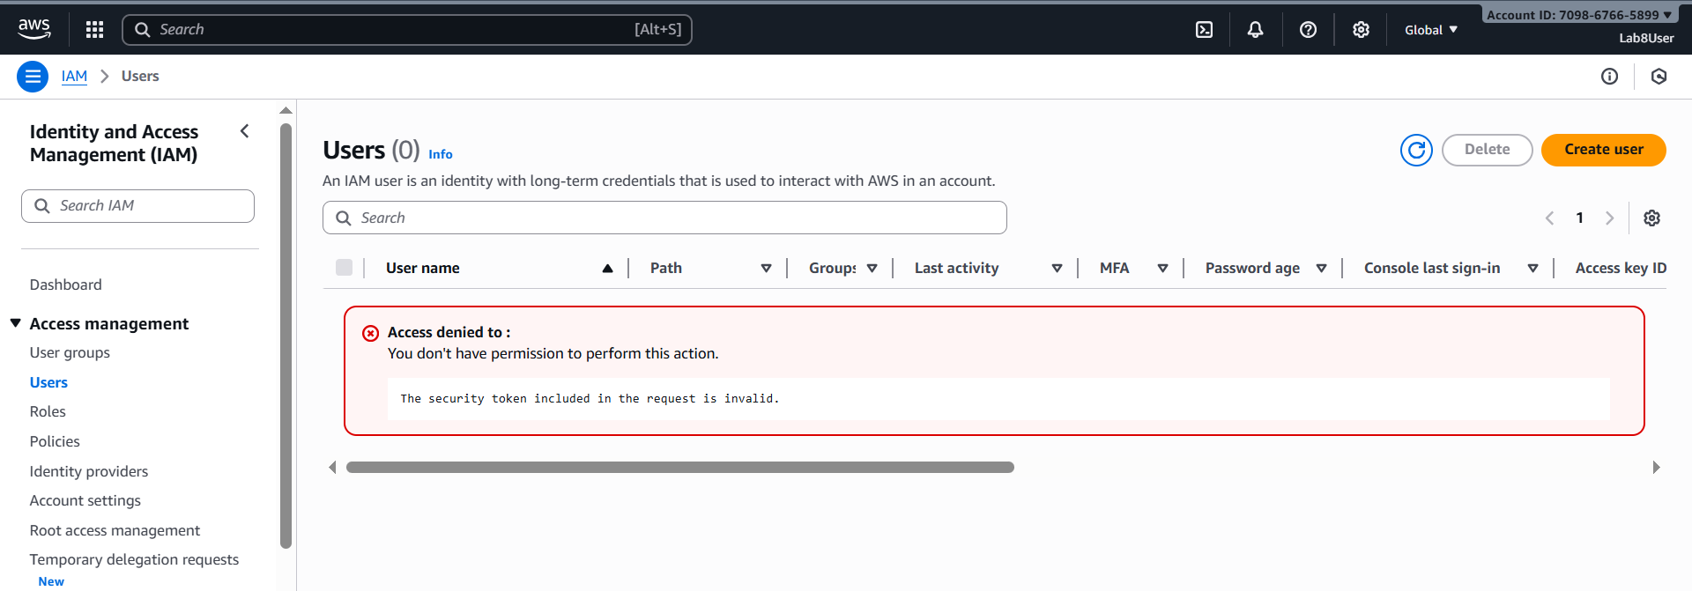

1. **Final cleanup summary (show billing or resource groups with no active resources if possible).**

**Save screenshot as: cleanup_summary.png — AWS console Billing/Resource Groups showing no active resources or no recent charges (if available).**



